CPRG-352

Web Application Programming

# Assignment #1 – Basic Web Application

## Problem

You are asked to create a Java web application called **Home Inventory**. This application will allow users to keep track of their household items for the purpose of home insurance. Administrators have the ability to view a summary of inventory information.

## Functionality

1. The initial page is a login page located at /login

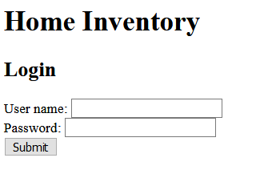

1. An unsuccessful login attempt displays the following page.

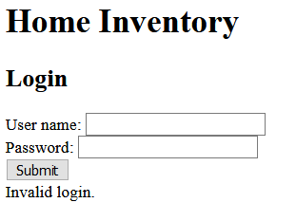

1. After successful logging in with a correct username/password pair, the browser redirects the user to /inventory and displays the following page. This page displays the authenticated user’s username, a form for adding an item to their inventory, and the total value of all of the user’s items. The drop box for category contains the following choices: bedroom, garage, kitchen, living room.

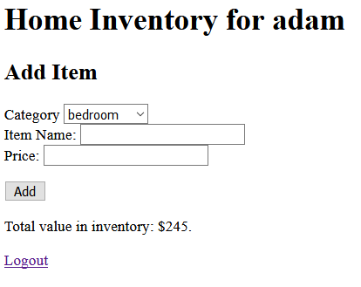

1. If the user enters invalid information, display an error message.

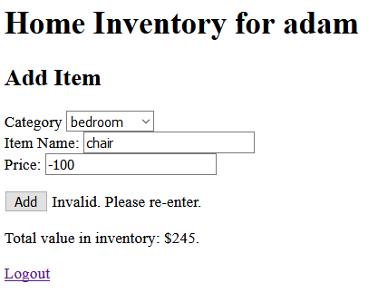

1. Upon adding an item, the item information is saved in the file “homeitems.txt” located in the WEB-INF folder. The structure of homeitems.txt should be comma delimited. E.g.

adam,bedroom,chair,100

The initial dashboard should be displayed again with a message. The total value of the inventory is updated.

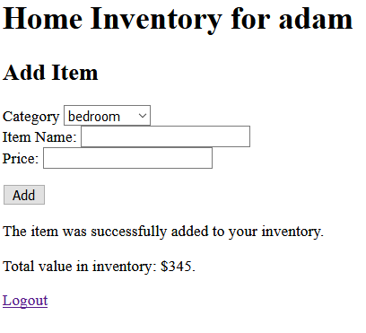

1. Clicking logout, returns the user to the login page.

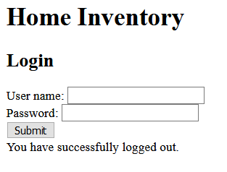

1. If the user enters the proper credentials for the administrator (admin/password), redirect the browser to the admin page where a summary of the inventory items is displayed. The total value is a sum of all the prices in the text file.

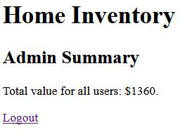

For a bonus of 1 mark, display the following instead.

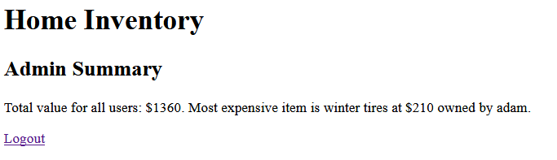

## Error Checking Requirements

* At no point should the application crash by entering invalid inputs.
* Category, item name, and price cannot be left blank. Price must be greater than 0 and less than 10000. **You must perform error checking on the server.** Client-side error checking (i.e. JavaScript or HTML form constraints) is optional. You are not required to distinguish between which textbox caused the error or why.

## Security Requirement

* Only the user with the username “admin” can access the admin page. Other users are redirected to the login page.
* Only authenticated (logged in) users can access the inventory page. (An admin could access this page if they want to.) Unauthenticated users are redirected to the login page.

## Design Requirement

* You must use the supplied users.txt and homeitems.txt as is.
* You must have the correct usage for nullipotent, idempotent, and non-idempotent actions with regards to GET and POST. In particular, logging in and adding an inventory item are POST actions. Everything else must be GET.
* The solution you create for this assignment must follow the MVC design pattern.

## Tips

1. Suggested file structure:

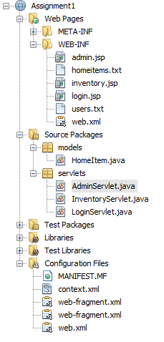

1. Suggested URL mapping.
   1. /login -> LoginServlet
   2. /inventory -> InventoryServlet
   3. /admin -> AdminServlet
2. Accessing files from a servlet is a bit different than from a Java application. In particular, the path of the file is relative to the project root, not the drive root. Here is some code to help you:

String path = getServletContext().getRealPath("/WEB-INF/homeitems.txt");

// to read files  
BufferedReader br = new BufferedReader(new FileReader(new File(path)));

// to append to a file  
PrintWriter pw = new PrintWriter(new BufferedWriter(new FileWriter(path, true)));

## ****Marking Scheme****

Correct functionality: 5/5  
Bonus admin functionality: +1  
NetBeans Project structure/File names/Routing: 1/1  
Coding style: 1/1  
Error checking: 1/1  
Security: 1/1  
Periodic Git commits, Git comments: 1/1